#### SPRINT – 1

### Project Title: Personal Assistance for Seniors Who Are Self-Reliant

### Team ID: PNT2022TMID14299

### Created and launched the IBM Watson IoT platform:

### 

Connected IBM IOT watson cloud with wokwi(nodemcu)

Wokwi link: [**https://wokwi.com/projects/348318659842671188**](https://wokwi.com/projects/346404308518961748)

**Code:**

#include<WiFi.h>//library for wifi module #include<PubSubClient.h>//library for MQTT void callback(char* subscribetopic, byte* payload,unsigned int payloadlength);

//---------------credentials of IBM Account------

#define ORG "88ju36"//IBM ORGANITION ID

#define DEVICE_TYPE "Ultrasonic"//Device type mentioned in ibm watson IOT Platform

#define DEVICE_ID "1"//Device ID mentioned in ibm watson IOT Platform

#define TOKEN "12345678" //Token

String data3;

float dist;

//------------customize the above value char server[]=ORG

".messaging.internetofthings.ibmcloud.com";//server name char publishtopic[]="ultrasonic/evt/Data/fmt/json";/*topic name and type of event perform and format in which data to be send*/

char subscribetopic[]="ultrasonic/cmd/test/fmt/String";/*cmd REPRESENT Command tupe and COMMAND IS TEST OF FORMAT STRING*/char authMethod[]="use-token- auth";//authentication method char token[]=TOKEN; char clientid[]="d:" ORG ":" DEVICE_TYPE":" DEVICE_ID;//CLIENT ID

//

WiFiClient wifiClient;// creating an instance for wificlient PubSubClient client(server, 1883 , wifiClient); void setup()

{

Serial.begin(115200); wificonnect(); mqttconnect();

}

void loop()//recursive function

{

if (!client.loop()){ mqttconnect();

}

}

/*...............................................retriving to cloud. */

void mqttconnect(){ if(!client.connected()){ Serial.print("Reconnecting client to "); Serial.println(server); while(!!!client.connect(clientid,authMethod, token)){ Serial.print("."); delay(500); }

initManagedDevice(); Serial.println();

}

else{ Serial.println("Connected :)");

} } void wificonnect()//function defenition for wificonnects

{

Serial.println(); Serial.print("Connecting to ");

WiFi.begin("Wokwi-GUEST", "",6);//PASSING THE WIFI CREDIDENTIALS TO ESTABLISH CONNECTION

while (WiFi.status() !=WL_CONNECTED){delay(500); Serial.print(".");

}

Serial.println(""); Serial.println("WiFi connected"); Serial.println("IP address"); Serial.println(WiFi.localIP());

} void initManagedDevice(){ if(client.subscribe(subscribetopic)){ Serial.println((subscribetopic)); Serial.println("subscribe to cmd OK");

}else{

Serial.println("subscribe to cmd failed");

}

}

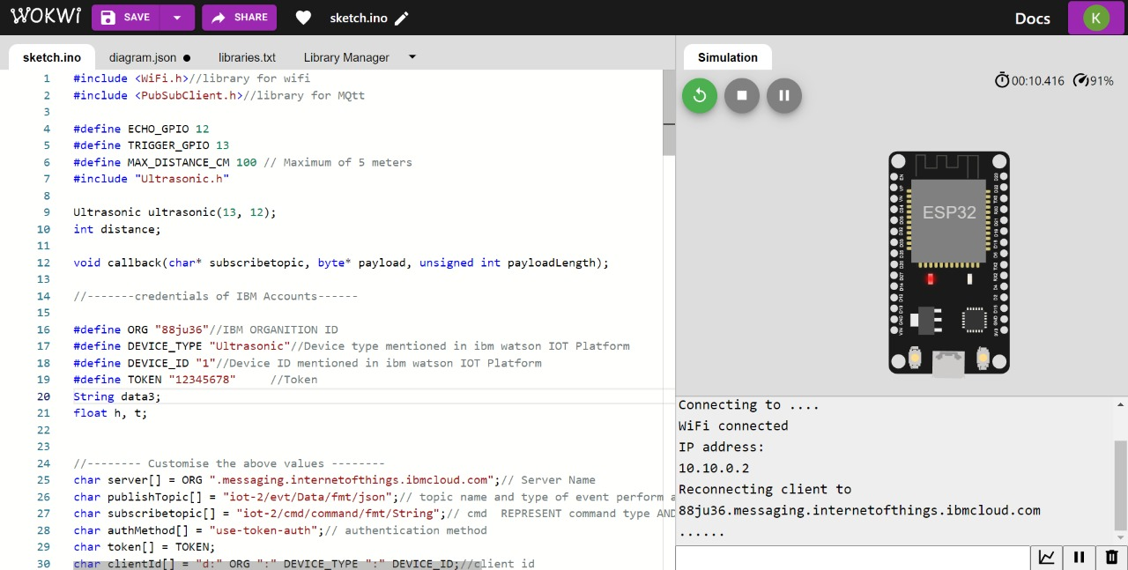

### Jira process: